**P. RAMI REDDY MEMORIAL COLLEGE OF PHARMACY**

**DEPARTMENT OF PHARMACEUTICAL ANALYSIS**

**44/35-1, Prakruthi Nagar, Utukur, Kadapa – 516 003 A.P.**

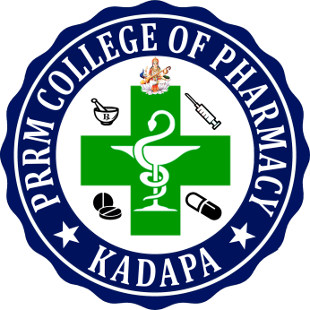

**PLAGIARISM CERTIFICATE**

We here by certify that **NAGINENI MANASA (Reg. no:15441S0706)** and **Mr.T. VIMALAKKANNAN, M.pharmacy., project guide** are the sole authors of this project report entitled **“ANALYTICAL METHOD DEVELOPMENT AND VALIDATION FOR SIMULTANEOUS ESTIMATION OF ROSUVASTATIN AND FENOFIBRATE IN TABLET DOSAGE FORM BY USING RP-HPLC METHOD”** and that neither any part nor the whole of this project report has been submitted for a degree by other student(s) to any other University or Institution.

We have checked the write up of the present project report using anti-plagiarism software and it is in the allowable limit **28%**. In case of any complaints pertaining to plagiarism, we also certify that we shall be solely responsible for the same and we understand that as per norms, University can even revoke the degree conferred upon the students(s) submitting this project report, in case it has found to be plagiarized.

**Signature of the Student Signature of the Guide**